Design and Implementation of a Microcontroller-Based Smart Sensor System
1. Project Overview
This project focuses on designing and implementing a microcontroller-based smart sensor system to monitor room occupancy and movement patterns in real-time. The primary objective is to support energy conservation, automation, and smart home functionality.
- Phase One: Implemented a single-node system using ultrasonic sensors to detect occupancy and estimate position within a room.
- Phase Two: Expanded to a multi-sensor wireless monitoring system, integrating Wi-Fi, Firebase cloud database, a Python-based base station for data aggregation, and a real-time dashboard for visualization. Alerts were added for inactivity and close-object detection.
2. Background Research
2.1 Real-Time Embedded Monitoring
O’Brien’s system tracks Alzheimer’s patients at home without wearables. It uses passive and active sensors to locate individuals in specific zones. The system sends data wirelessly for analysis and includes web access. This informed the project’s non-invasive, quadrant-based design.
2.2 Omnidirectional Camera Sensors
Callemein et al. use low-res, privacy-safe cameras on a Raspberry Pi. Their system detects occupancy using neural inference and self-training. It offers an alternative to PIR sensors and shows how minimal hardware can support smart sensing.
3. System Goals
3.1 Energy Control
Reduce energy waste by automatically controlling devices such as:
- Lights
- HVAC systems
- Fans and small appliances
When no motion is detected for a defined period, the system can switch devices to eco-mode or turn them off.
3.2 Smart Home Features
Supports automation scenarios such as:
- Mood lighting when someone enters
- Music or ambient setting activation
- Pausing media playback when the room is empty
4. Implementation Details
4.1 Arduino Code
Main functions implemented:
- Reading three ultrasonic sensors for distance measurements.
- Estimating user location based on sensor readings.
- Detecting stillness using a movement threshold for a configurable duration.
- Displaying raw sensor data and location estimate on an LCD.
- Sending JSON-formatted sensor data over Serial to the base station.
- Sending an EMAIL_TRIGGER signal when stillness exceeds the threshold.
- Outputs sensor readings in JSON format for integration with Python.
- Location estimation retained for LCD display.
4.2 Python Script
The base station performs the following:
- Reads JSON data from Arduino over Serial.
- Uploads sensor readings to Firebase Realtime Database for cloud storage.
- Logs readings locally using SQLite.
- Hosts a Flask-based web dashboard for real-time visualization using Chart.js.
- Sends email alerts through Mailtrap SMTP when:
  - Stillness detected for a set duration.
  - Object detected within a defined threshold (e.g., <10 cm).

Files:
- arduino_sketch.ino – Arduino code for data collection and LCD display.
- base_station.py – Python script for serial communication, cloud integration, and email alerts.
- templates/dashboard.html – Real-time visualization dashboard.

4.3 Cloud Integration
- Firebase Realtime Database chosen for cloud storage.
- Data structure:
{
"timestamp": "2025-08-03T14:23:12",
"S1": 123,
"S2": 145,
"S3": 134
}
- Dashboard fetches latest values every 2 seconds.

5. Circuit Diagram, Components List and Block Diagram

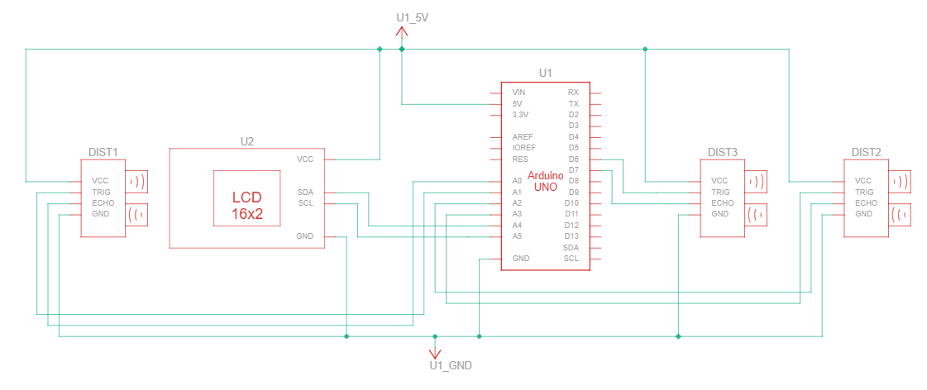
Figure 1: Circuit Diagram

Name | Quantity | Component
U1 | 1 | Arduino Uno R3
U2 | 1 | MCP23008-based, 32 (0x20) LCD 16 x 2 (I2C)
DIST1  DIST2  DIST3 | 3 | Ultrasonic Distance Sensor (4-pin)

Table 1: Component List

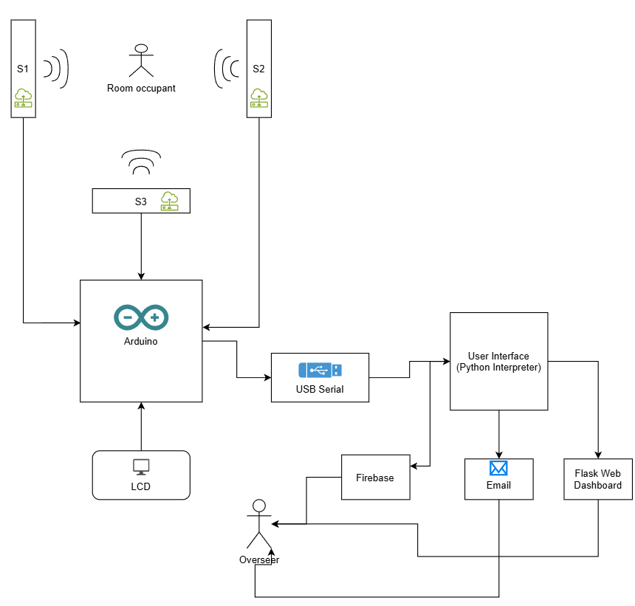
Figure 2: Block Diagram

6. Data Analysis and Visualization
- Data streamed in real-time charts using Chart.js via Flask.
- Firebase allows remote access and historical tracking.
- Example Dashboard:
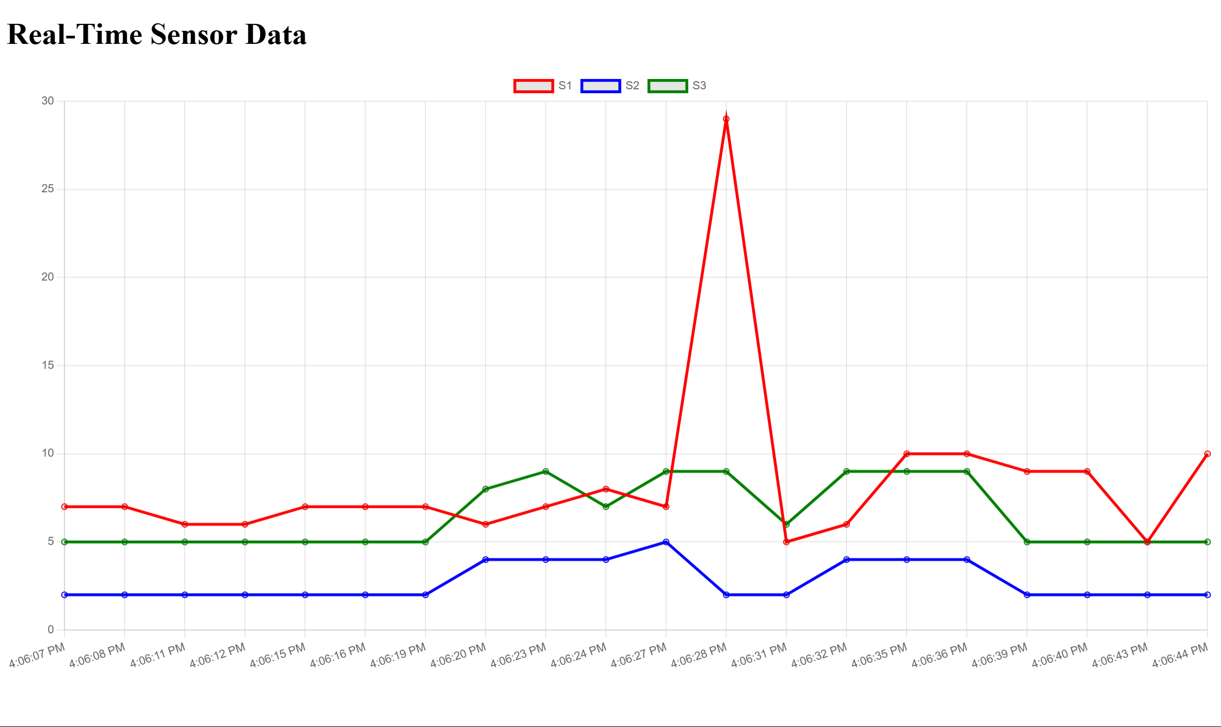
Figure 3: Real Time Sensor Data

7. Testing and Results

- Tested with simulated movement by moving objects near sensors.
- Stillness detection worked accurately within ±1 cm tolerance.
- Email alerts successfully sent using Mailtrap.
- Firebase logs verified in Realtime Database console.
- Dashboard updated live with new readings every 2 seconds.

8. Conclusion and Reflection

This project demonstrates how low-cost sensors and open-source tools can implement an IoT-based smart monitoring system for home automation and energy efficiency.
Lessons Learned
- Real-time IoT integration requires robust handling of serial data and JSON parsing.
- Adding Firebase and a dashboard significantly improves system usability.
- Balancing code complexity and system responsiveness is key for embedded systems.
Future Work
- Expand system with ESP32 nodes for true wireless deployment.
- Add historical trend analysis in dashboard.
- Implement MQTT for scalable multi-node communication.

Appendix A: Arduino Code
#include <Wire.h>
#include <LiquidCrystal_I2C.h>

LiquidCrystal_I2C lcd(0x27, 16, 2);

// Ultrasonic sensor pins
#define trigPin1 A1
#define echoPin1 A0
#define trigPin2 A3
#define echoPin2 A2
#define trigPin3 6
#define echoPin3 7

long duration;
long FIRSTSensor, SECONDSensor, THIRDSensor;

// Movement tracking
unsigned long lastChangeTime = 0;
unsigned long currentTime;
const unsigned long STILL_DURATION = 10000; // 10 seconds
const int STILL_THRESHOLD = 5; // cm tolerance

long lastS1 = 0, lastS2 = 0, lastS3 = 0;
bool isStill = false;
bool emailSent = false;

void setup() {
Serial.begin(9600);
lcd.init();
lcd.backlight();

pinMode(trigPin1, OUTPUT); pinMode(echoPin1, INPUT);
pinMode(trigPin2, OUTPUT); pinMode(echoPin2, INPUT);
pinMode(trigPin3, OUTPUT); pinMode(echoPin3, INPUT);

lcd.setCursor(0, 0); lcd.print("Initializing");
delay(2000); lcd.clear();
}

void loop() {
currentTime = millis();

FIRSTSensor = readUltrasonic(trigPin1, echoPin1);
SECONDSensor = readUltrasonic(trigPin2, echoPin2);
THIRDSensor = readUltrasonic(trigPin3, echoPin3);

// Send JSON over Serial for Python
Serial.print("{\"S1\":");
Serial.print(FIRSTSensor);
Serial.print(",\"S2\":");
Serial.print(SECONDSensor);
Serial.print(",\"S3\":");
Serial.print(THIRDSensor);
Serial.println("}");

// Display on LCD
lcd.setCursor(0, 0);
lcd.print("S1:"); lcd.print(FIRSTSensor);
lcd.print(" S2:"); lcd.print(SECONDSensor);

lcd.setCursor(0, 1);
lcd.print("S3:"); lcd.print(THIRDSensor);
lcd.print(" ");
lcd.print(estimateLocation(FIRSTSensor, SECONDSensor, THIRDSensor));

delay(1000);
lcd.clear();

// Stillness check
bool s1Still = abs(FIRSTSensor - lastS1) < STILL_THRESHOLD;
bool s2Still = abs(SECONDSensor - lastS2) < STILL_THRESHOLD;
bool s3Still = abs(THIRDSensor - lastS3) < STILL_THRESHOLD;

if (s1Still && s2Still && s3Still) {
if ((currentTime - lastChangeTime) >= STILL_DURATION && !isStill) {
isStill = true;
if (!emailSent) {
Serial.println("EMAIL_TRIGGER"); // For Python alert
emailSent = true;
}
}
} else {
lastChangeTime = currentTime;
isStill = false;
emailSent = false;
}

lastS1 = FIRSTSensor;
lastS2 = SECONDSensor;
lastS3 = THIRDSensor;
}

long readUltrasonic(int trigPin, int echoPin) {
digitalWrite(trigPin, LOW);
delayMicroseconds(2);
digitalWrite(trigPin, HIGH);
delayMicroseconds(10);
digitalWrite(trigPin, LOW);

duration = pulseIn(echoPin, HIGH, 25000); // 25ms timeout
if (duration == 0) return 999; // Max distance if no echo
return (duration / 2) / 29.1;
}

// Location estimation for LCD only
String estimateLocation(long s1, long s2, long s3) {
const float roomDepth = 8.9; // cm
const float roomWidth = 8.9; // cm

const float centerTarget = 4.5;
const int centerTolerance = 1;
const int backThreshold = 8;
const int sideTolerance = 1;

if (abs(s1 - centerTarget) <= centerTolerance &&
abs(s2 - centerTarget) <= centerTolerance &&
abs(s3 - centerTarget) <= centerTolerance) {
return "Center";
}

bool nearBack = s1 < backThreshold;
int sideDiff = s2 - s3;

if (nearBack) {
if (abs(sideDiff) <= sideTolerance) {
return "BackCtr";
} else if (sideDiff > sideTolerance) {
return "BackLeft";
} else {
return "BackRight";
}
} else {
if (abs(sideDiff) <= sideTolerance) {
return "FrontCtr";
} else if (sideDiff > sideTolerance) {
return "FrontLeft";
} else {
return "FrontRight";
}
}
}

Appendix B: Python Script
import serial
import time
import json
import smtplib
import sqlite3
import requests
from email.message import EmailMessage
from flask import Flask, render_template, jsonify
from threading import Thread

# ==== CONFIG ====
SERIAL_PORT = 'COM7'
BAUD_RATE = 9600
FIREBASE_URL = "https://yourprojectID.firebaseio.com/"
EMAIL_COOLDOWN = 10
last_email_time = 0

# Mailtrap SMTP credentials
SMTP_SERVER = "sandbox.smtp.mailtrap.io"
SMTP_PORT = 2525
EMAIL_USERNAME = "4b7ada0ea947b8"
EMAIL_PASSWORD = "80d3fecb4d88e5"
EMAIL_FROM = "Motion Sensor <motionarduinoproj@gmail.com>"
EMAIL_TO = "chvistopher@gmail.com"

# ==== SETUP ====
ser = serial.Serial(SERIAL_PORT, BAUD_RATE)
time.sleep(2)

# SQLite DB setup
conn = sqlite3.connect('sensor_data.db', check_same_thread=False)
cursor = conn.cursor()
cursor.execute('''CREATE TABLE IF NOT EXISTS readings
(timestamp TEXT, S1 INTEGER, S2 INTEGER, S3 INTEGER)''')

# Flask app for dashboard
app = Flask(__name__)
latest_data = {}

def send_email(message):
global last_email_time
if time.time() - last_email_time < EMAIL_COOLDOWN:
return
msg = EmailMessage()
msg.set_content(message)
msg['Subject'] = "Motion Alert"
msg['From'] = EMAIL_FROM
msg['To'] = EMAIL_TO
try:
with smtplib.SMTP(SMTP_SERVER, SMTP_PORT) as smtp:
smtp.starttls()
smtp.login(EMAIL_USERNAME, EMAIL_PASSWORD)
smtp.send_message(msg)
print("Email sent:", message)
last_email_time = time.time()
except Exception as e:
print("Failed to send email:", e)

@app.route('/')
def index():
return render_template('dashboard.html')

@app.route('/data')
def data():
return jsonify(latest_data)

def serial_reader():
global latest_data
while True:
try:
line = ser.readline().decode().strip()
if not line:
continue
if line == "EMAIL_TRIGGER":
send_email("Alert: Person has been still for over 1 minute.")
continue
data = json.loads(line)
latest_data = data
print("Received:", data)

# Log to SQLite
timestamp = time.strftime('%Y-%m-%d %H:%M:%S')
cursor.execute("INSERT INTO readings VALUES (?, ?, ?, ?)",
(timestamp, data['S1'], data['S2'], data['S3']))
conn.commit()

# Push to Firebase
try:
requests.post(FIREBASE_URL, json=data)
except Exception as e:
print("Firebase error:", e)

# Check for close object alert
if any(int(v) < 10 for v in data.values()):
send_email("Alert:Person detected within 10 cm!")
except Exception as err:
print("Error:", err)
time.sleep(1)

if __name__ == '__main__':
Thread(target=serial_reader, daemon=True).start()
app.run(host='0.0.0.0', port=5000, debug=False)

Appendix C: HTML Script
<!DOCTYPE html>
<html>
<head>
<title>Sensor Dashboard</title>
<script src="https://cdn.jsdelivr.net/npm/chart.js"></script>
</head>
<body>
<h1>Real-Time Sensor Data</h1>
<canvas id="chart" width="400" height="200"></canvas>

<script>
async function fetchData() {
const res = await fetch('/data');
return res.json();
}

const ctx = document.getElementById('chart').getContext('2d');
const chart = new Chart(ctx, {
type: 'line',
data: {
labels: [],
datasets: [
{label: 'S1', data: [], borderColor: 'red', fill: false},
{label: 'S2', data: [], borderColor: 'blue', fill: false},
{label: 'S3', data: [], borderColor: 'green', fill: false}
]
}
});

async function updateChart() {
const data = await fetchData();
const timeLabel = new Date().toLocaleTimeString();
if (data.S1 !== undefined) {
chart.data.labels.push(timeLabel);
chart.data.datasets[0].data.push(data.S1);
chart.data.datasets[1].data.push(data.S2);
chart.data.datasets[2].data.push(data.S3);
if (chart.data.labels.length > 20) {
chart.data.labels.shift();
chart.data.datasets.forEach(ds => ds.data.shift());
}
chart.update();
}
}

setInterval(updateChart, 2000);
</script>
</body>
</html>

